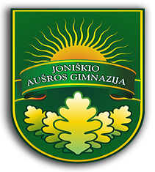
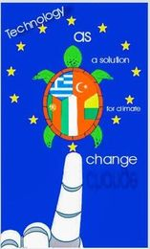

Erasmus + KA229 project
No: 2020-1-EL01-KA229-078939_5
“TECHNOLOGY AS A SOLUTION FOR CLIMATE CHANGE “
Mobility in Joniškis, Lithuania
From 20.03.2022 to 26.03.2022
AGENDA
Sunday 20-03
Arrivals
Monday 21-03
8.00 – Lesson with the host students
9.00 - Meeting ceremony at school
9.30 – 10.30 – Introducing the program of the week
Excursion around the school
10.30 – 11.00 – Break
11.00 - 12.00 – Workshop: quality of water (chemistry room) 12.00 – 13.00 - Lunch at school
13.00 – 13.30 – Presentation of partner country including the topic: “A few minutes for a greener and more livable World” and “How do we celebrate the Earth day in our school, city and country?” Turkey and Lithuania
14.00 – 16.00 – Trip to Joniškis town, Local government, “Saulė” basic school (teachers)
14.00 – 16.00 - Orienting activity for students
17.00 – Return to the host families (teachers to the hotel)
18.00 – Dinner for teachers (students will have dinner with host families)

Tuesday (22.03)
8.00 – Lesson with the host students
9.00 – Leaving to Riga (cultural day)
Full day trip in Riga
17.00 – 18.00 – coming back to Joniškis
18.00 - dinner for teachers (students will have dinner with host families)

Wednesday (23.03)
8.00 – Lesson with the host students
9.15 – 10.00 – Presentations of the results of workshop
10.00 – 10.30 – Break
10.30 – Workshop (biology laboratory)
12.00 – 12.30 – Lunch
12.30 - Trip to Šiauliai (chocolate manufactory, walking in the open air “Fox path”)
14.00 – chocolate manufacture
15.30 – 16.30 - Back to Joniškis (hill of crosses on a way back)
17.00 – Back to host families (teachers to the hotel)
19.00 – Dinner for teachers (students will have dinner with the host families)

Thursday (24.03)
8.00 – Lesson with host students
9.00 – Departure to Pakruojis
10.30 - Guided tour
12.00 – Lunch in Pakruojis
14.30 – Back to Joniškis
15.00 - Summary, certificates
16.00 – Students to host families, teachers to the hotel
18.00 – Good bye party (teachers and students)

Friday (25.03)
9.00 – Meeting at school
9.15 – Departure to Vilnius
11.30 – Arrival at the hotel
12.00 – Lunch in Vilnius
13.30 – Guided tour of old Vilnius town
16.00 – Free time

Saturday (26.03)
Departure to Stambul

